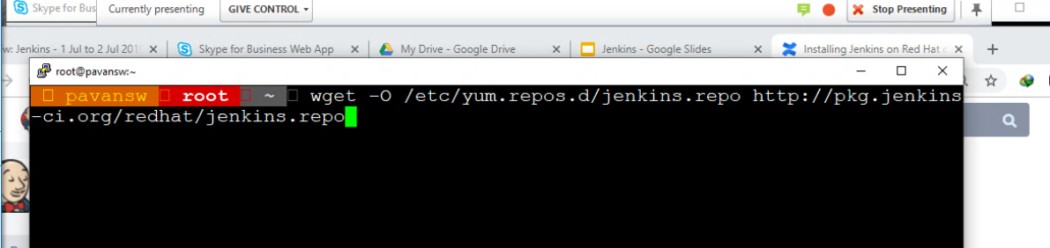

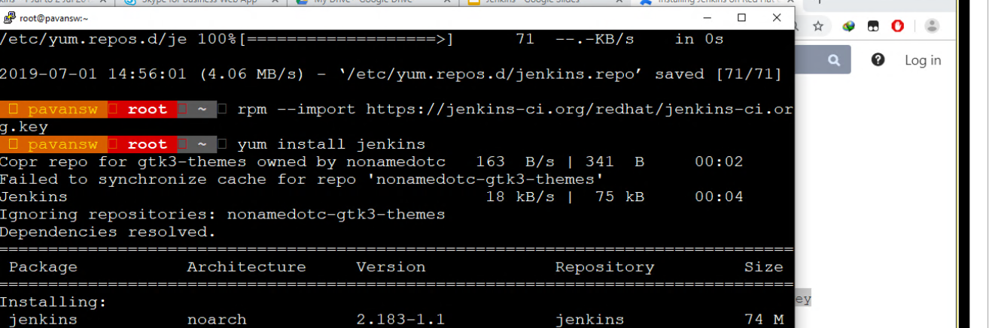

firewall-cmd --permanent --service=jenkins --add-port=8080/tcp

firewall-cmd --permanent --add-service=jenkins

firewall-cmd --zone=public --add-service=http --permanent

firewall-cmd --reload

sudo iptables -A PREROUTING -t nat -i eth0 -p tcp --dport 80 -j REDIRECT --to-port 8080

sudo sh -c "iptables-save > /etc/iptables.rules"

<https://wiki.jenkins.io/display/JENKINS/Installing+Jenkins+on+Red+Hat+distributions>